Hormuz: Strait into a new geopolitical reality
Hormuz has been coined as the determinant. In practical terms: who controls Hormuz at the end of the conflict in reality won the war. Currently access is effectively blocked. This caused oil prices to rise but the secondary are the true inflationary time bombs. Think fertilizers, helium, synthetic fibers, etc. which you don’t pay for at the cashier. Yet. Let’s go into more detail before this Easter weekend as the coming days might give more insight in what will actually happen.
Three relevant outcomes
We can define three likely outcomes for the nearby future:
- Conflict continues as is
- Conflict escalates
- US walks away one sided, calling themselves victorious
Also one low chance probability outcome, that would be best for the world.
Conflict continues as is. Stagflation.
All that transpired in the last few weeks is inflationary. It’s visible already at gasoline prices but all secondary effects are still to come (e.g. crop prices). The FED made a good analysis of the impact of oil price shocks on inflation: (https://www.federalreserve.gov/econres/notes/feds-notes/oil-price-shocks-and-inflation-in-a-dsge-model-of-the-global-economy-20240802.html#fig1) A 10 dollar increase in oil would increase inflation with roughly 30 bps. It also impacts growth, real GDP is lowered with 15 bps. Current shock to oil price is well in excess of $10 so the impact would be enormous and we can type stagflation in caps. When the conflict continues as is, inflation impact will be even larger and negative impact on global growth as well. A high level of uncertainty remains and the market dislikes nothing as much as it does uncertainty. It will be a huge dampener on markets going forward.
Eventually a new balance will be found. Oil will find it’s way out without Hormuz. Although, based on discussions between Iran and Oman it might also find it way out through Hormuz. Just with tolls being paid increasing the cost of business, but at least oil gets out. The latter solution will not be as painful economically compared to a continued closing of Hormuz. It does risk tolls being instituted in other Straits, breaking the ‘Mare Liberum’ (thank you Hugo Grotius). We can already seeing the number of ships through Hormuz increasing, supposedly due to toll system:
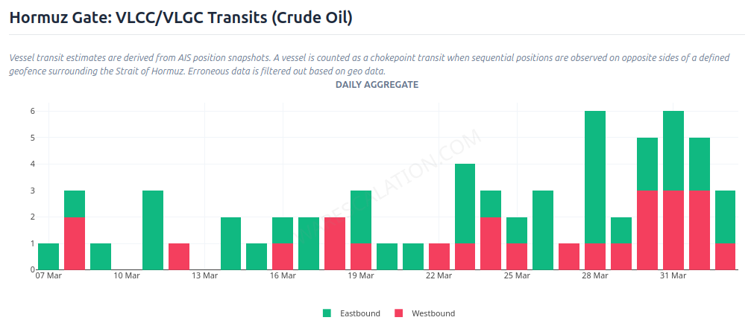
(source: Warescalation.com)

Conflict escalates. V for victory?
Trump has claimed victory many times, yet wants to pummel Iran for several weeks extra (at least). Iran has met every escalation by US/Israel in kind. If US/Israel does move to striking energy and desalination infrastructure Iran’s logical response will be to hit similar targets in Gulf countries (with US military bases). That will create a long-term physical supply gap no claims of victory solve. Opening of Hormuz would not offset the loss in refining capacity.
Iran also has another ace up it’s sleeve: The Bab El-Mandeb Strait. Roughly 10% of oil moves through this Strait. This was blocked between 2023 and 2025 by the Houthi’s (allies to Iran) in Yemen. Insurance costs remain high and a lot of ships still opt to go through past the Cape in Africa which adds a lot of travel time. Furthermore, Saudi Arabia has diverted a lot of oil by pipelines from the Gulf to Yanbu at the Red Sea. This can then only be moved through the Suez canal. Further escalation could result in this Strait also being blocked and then oil prices would increase enormously again.
Escalation would be a catastrophic miscalculation. The market won’t be V shaped but lower for longer with inflation high for much longer. Higher and longer than under the previous scenario.
US walks away. What is the currency symbol for Yuan?
Despite the claims of victory Iran has a strong grip on Hormuz and is in control which ships can pass, which cannot. They have also made the Strait into a source of income as they levy tolls. In this scenario the Strait of Hormuz will open. Oil prices will drop (expectations are to around $90), as markets hate uncertainty more than taxes. However, the conditions under which Iran will likely open it are:
- Imposing tolls
- Settling in Yuan
- Vessel discrimination: No US/Israel associated ships can pass
- Sanctions effectively end
This has profound effects on the global economy. It risks other countries might impose tolls on different Straits as well (e.g. Malacca, Bab el-Mandeb). Insurance companies probably wouldn’t cover ships paying an ‘illegal’ toll breaking a foundation away from shipping and would probably mean insurance companies from e.g. China stepping in to fill the void. The Yuan would become a more important currency in the global economy, while that of the dollar would decline. As demand for dollars would drop it would also mean more inflation in the US. China would become the guarantor of the Strait of Hormuz, which will make the oil flow (they have good relations with all countries in the Gulf) but it would be an enormous change.
Alternative TACO route
An alternative would be that the US effectively appoint someone as the leader of Iran. Claiming he (sorry, will probably be a male) is the righteous leader of Iran and make a deal with him. US will claim oil and give the new leader some backing. With the hope that Iranians will support this ‘messias’ and able and willing to rise up against the IRGC. Effectively evoke a revolution. Chance of success? Hard to tell. It’s the only way out that would pacify the region but it’s not one easily orchestrated.
Acceptable solution?
The question is, which outcome does the US accept and realize? Easiest is to walk away and immediately oil prices will drop (as uncertainty premium disappears). They’d loose their standing and economic power alongside with it. It would be an enormous economic loss for the US. The US under Trump is not known for its well thought out economic policies but this would be a colossal failure. The other alternatives are not great either though, only the ‘alternative’ would lead to a somewhat favorable outcome. However, this is easier to do on paper than in reality and most likely ends up with IRGC still in charge and controlling Hormuz.
How to deal with uncertainty as an investor?
Truth is the first victim in a war. Both US and Iran can’t be trusted in their communications so we need to look at objective data and assume the actors act rationally (I created warescalation.com for this purpose). Walking away from the war is a real possibility by Trump but would have profound impacts on the global economy in general but the US specifically. The alternative is a much longer war and lots of avenues for escalation. Stagflation is already most likely scenario and escalation and longer war is the most likely outcome. There is a supply gap in oil which would become persistent and a risk of another spike with Bab El-Mendab. This would have further impact on inflation and global growth.
In short: The perspective is negative. There is no probable and cheap way out of it. Either we get a geopolitical reorganisation or continued war with inflation really hitting home and global growth negatively impact. So, position yourself for inflation. This is a certainty. Oil can drop but is more likely to go up, as are all second order processes of oil/gas. Fertilizers prices will impact crop prices and there are very few sectors that can benefit from current events. Personally, being exposed to VIX, Oil without much (if any) outright equity exposure seems to be a sensible approach. It positions for more turmoil while keeping the downside risk (which would be a massive relief rally) limited.

